

Search

David Murphy

25 June [Growth](https://messapps.com/tag/growth/)

**Boost Your App’s Growth: Social Implementations**

## Both Apple and Google trust that the amount of time users spend inside an app is indicative of its overall quality, and rank them accordingly.

To gauge both an app's quality and its overall ability to meet user expectations, both Google and Apple's app stores rely on how frequently and for how long users engage with the app in question. This data being mined is typically referred to as "Engagement Signals."

## Social implementations

intra­app communication give users another reason to frequent your app. A social feature's aim should be to increase interaction with other users and, in effect, with the app. All accessory features such as chat channels and social media compatibility should be easy to locate, yet non­intrusive. For instance, channels of communication between the user and developer are nifty, but only if the implementation seems warranted and users aren’t constantly reminded about the feature every single time they access the app.

Notifications are meant to redirect someone’s attention by way of some sort of alert: even if it’s just for a second, your reason for breaking someone’s focus *must* be justifiable. Although notifications tend to complement chats well, put careful thought into how

you implement them ­ especially push notifications. They can help, but only when they’re solicited; otherwise, they’ll only cause frustration, which will lead to uninstalls and mixed reviews.

Consider turn­based gaming apps; implementing push notifications that alert players when it’s their turn seems warranted. It might be unwise, however, to notify users about a new quest or challenge on a daily basis ­ the alerts get old, *fast*. Instead, consider emailing users, or even updating your app’s social media page on a daily basis for users to overlook. Otherwise, you can leave the choice for daily push notifications up to the user.

## Below is a conglomerate of ways that developers have integrated social aspects into their game.

**Reward users that want to share your app:**

**Miitomo** Developed by Nintendo

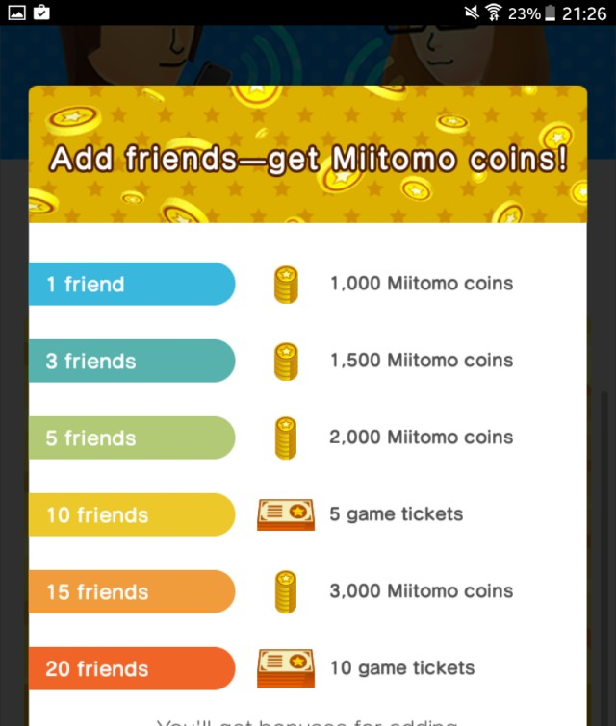

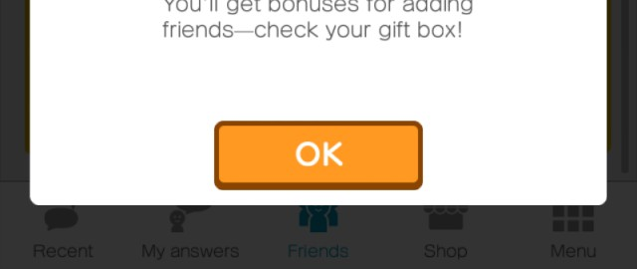

## Reward users for competing/interacting with other users to promote retention through competition:

**Clash of Clans** by Supercell

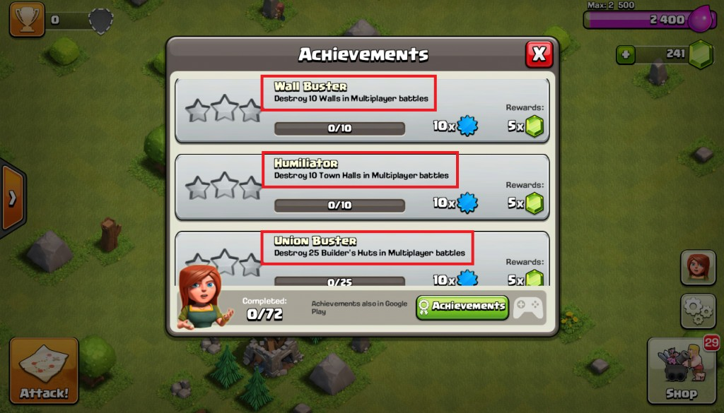

**Castle Clash** by IGG.COM

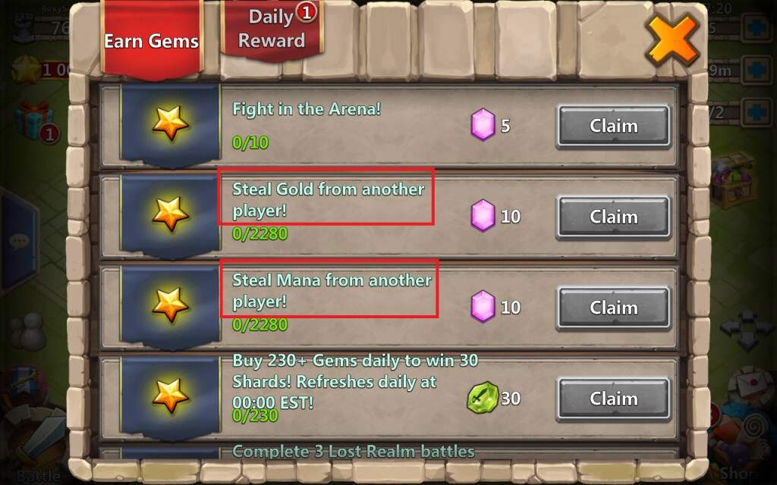

## Implement social networking into your app:

**Miitomo** Developed by Nintendo

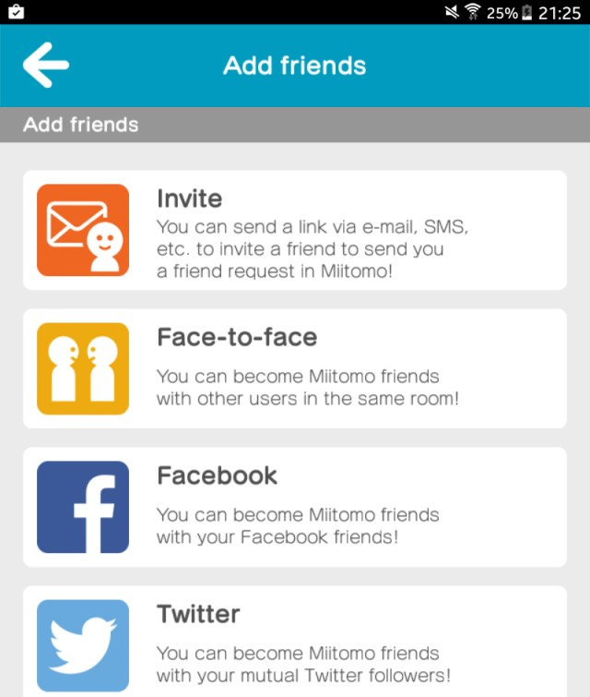

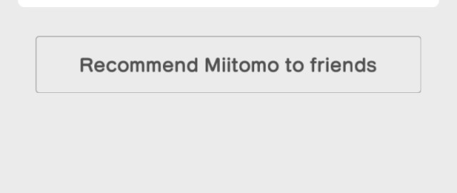

**Clash Of Lords 2** Developed by IGG.COM

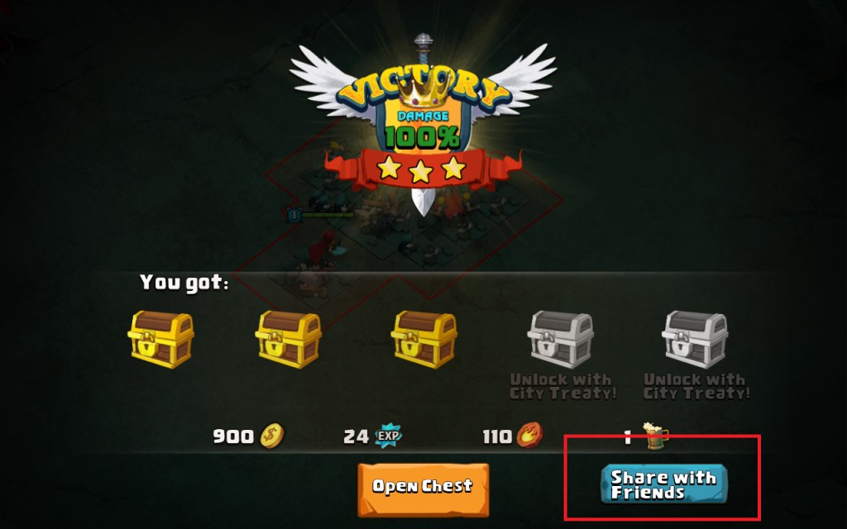

## Turn multiplayer into a feature that must be unlocked:

**Clash Royale** Developed by Supercell

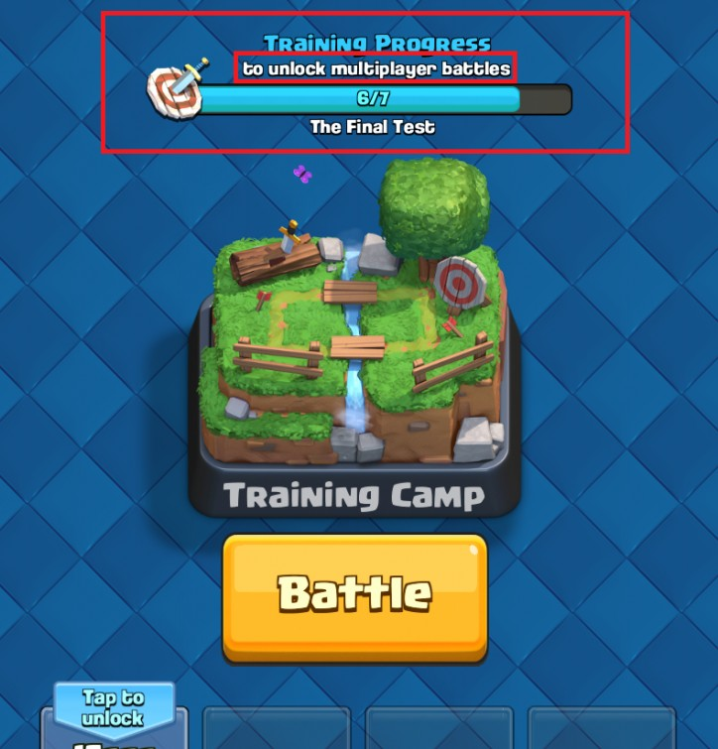

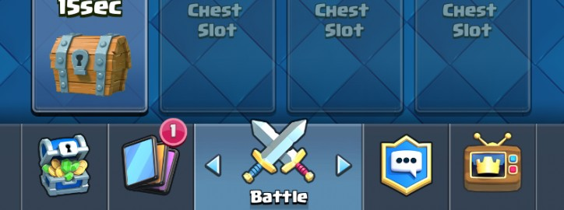

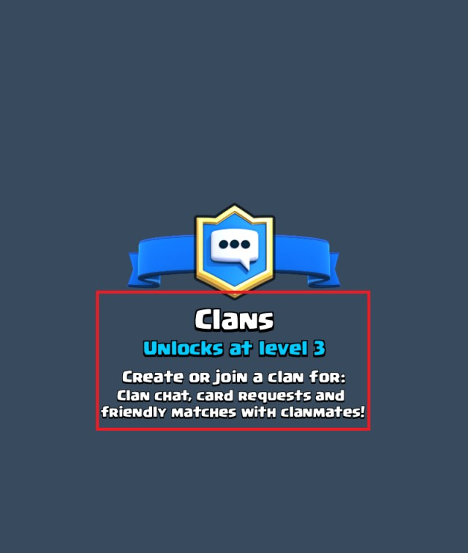

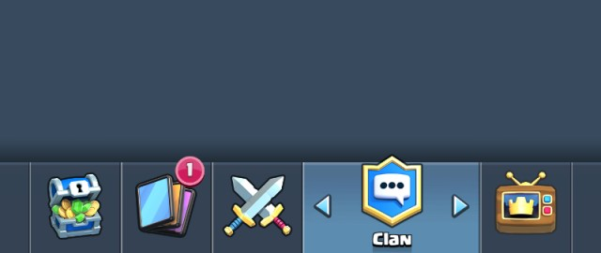

## Incorporate friends list and private messaging functionalities:

**Boom Beach** Developed by Supercell

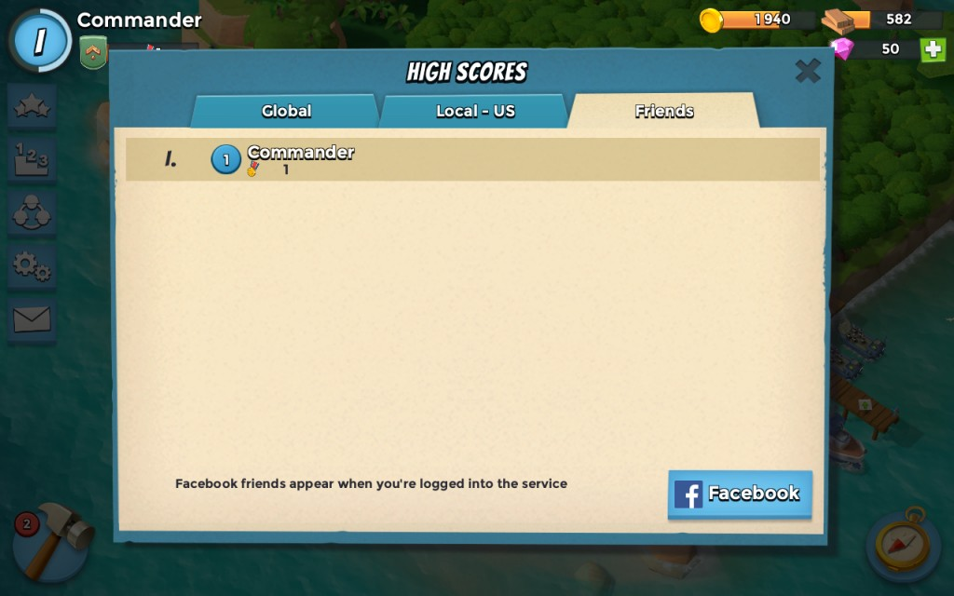

**Clash of Lords 2** Developed by IGG.COM

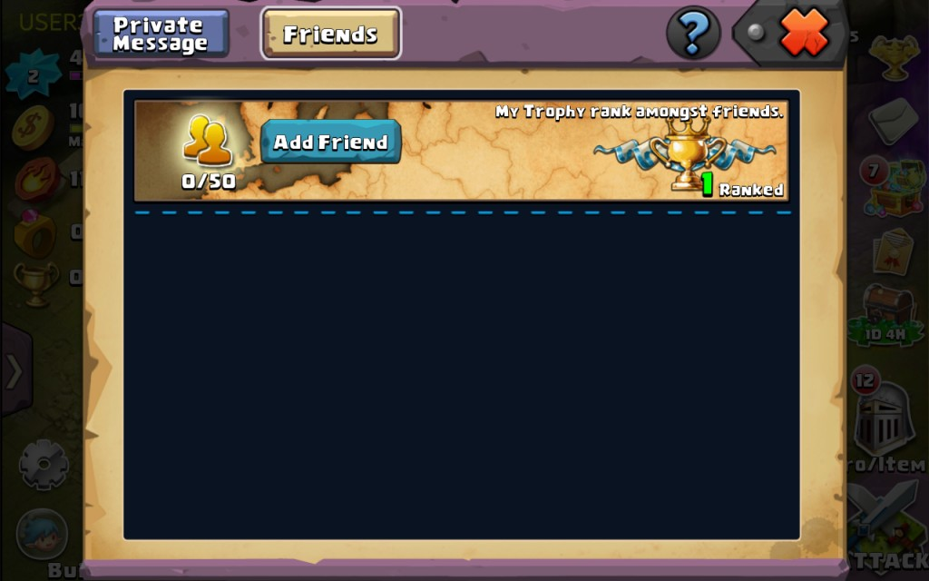

**Castle Clash** Developed by IGG.COM

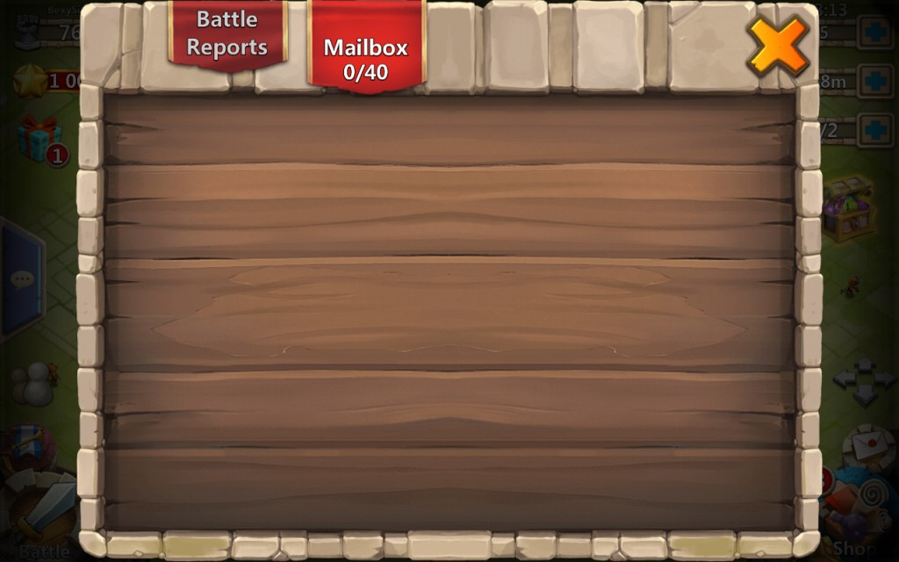

## Provide users with an open yet moderated chat channel that any user can type into:

**Castle Clash** by IGG.COM

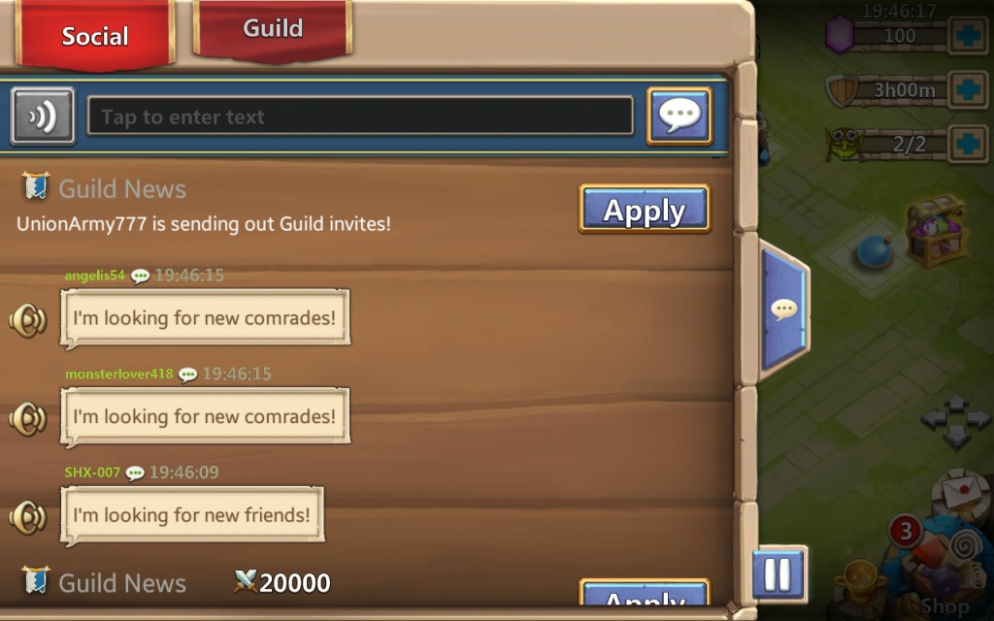

## Implement a guild­like system to elicit the growth of in­app communities:

**Clash of Lords 2** Developed by IGG.COM

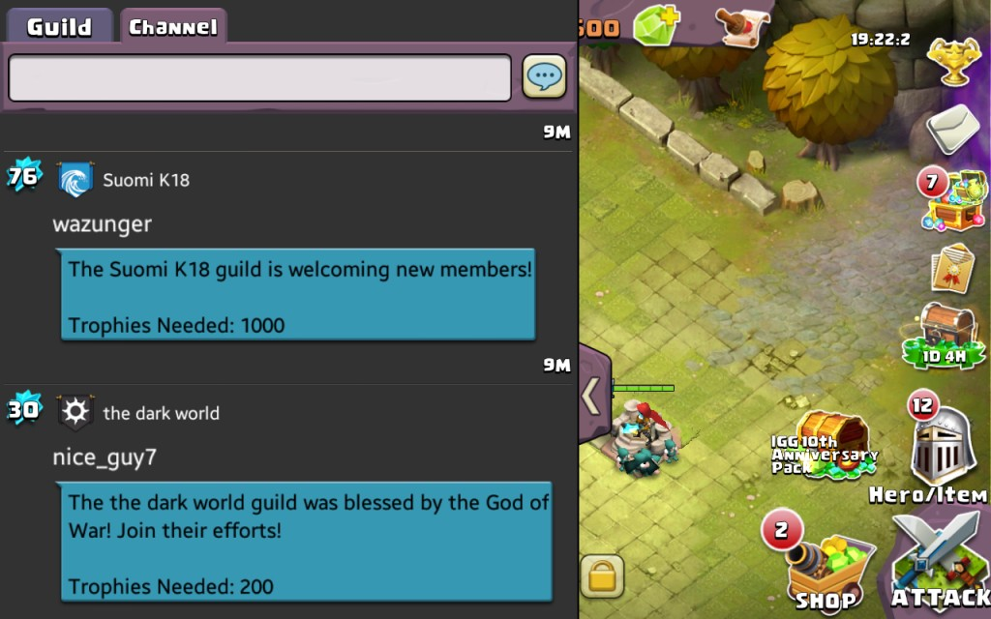

**Boom Beach** Developed by Supercell

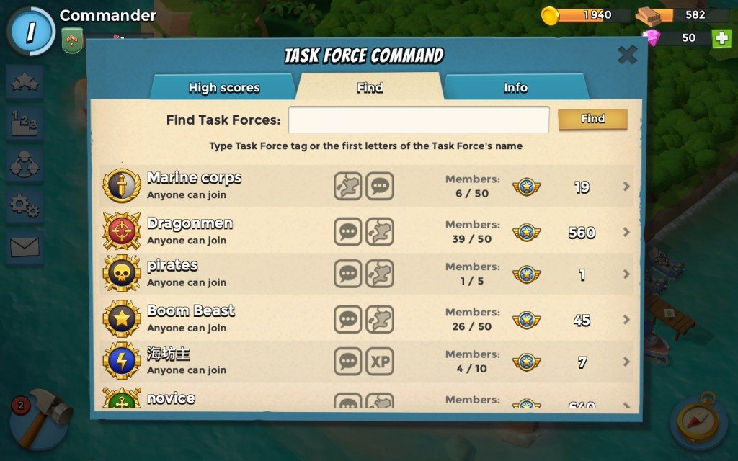

0

You might also like this articles

Dominick Wojtas



16 November

# [App Marketing 101](https://messapps.com/academy/articles/app-marketing-101/)

So you have an amazing app idea and the development process is moving along smoothly, so it must be impossible this app won’t be successful right? Wrong. Unfortunately, there are plenty of ways your app can fail. But we’re here to help you make sure that doesn’t happen.

0

Dominick Wojtas

04 June

# [11 of The Most Frequently Asked App Marketing Questions](https://messapps.com/academy/articles/11-frequently-asked-app-marketing-questions/)

Even though an app might be more innovative and responsive than another, both its reputation and discoverability will dictate how it performs on the e­ market. The stratagem surrounding e­marketing is in perpetual flux; the apps which reach their targeted audience the most effectively tend to be the most successful

0